Name: Manish Kumar

Admission Number: 20SCSE1010830

Section 10 Group P1

**Experiment 3**

**Aim**: To understand the use of Input command, print statement with format keyword, assignment operators, relational operators, logical operator, if-elif-else statements, list in python using jupyter notebook (Anaconda).

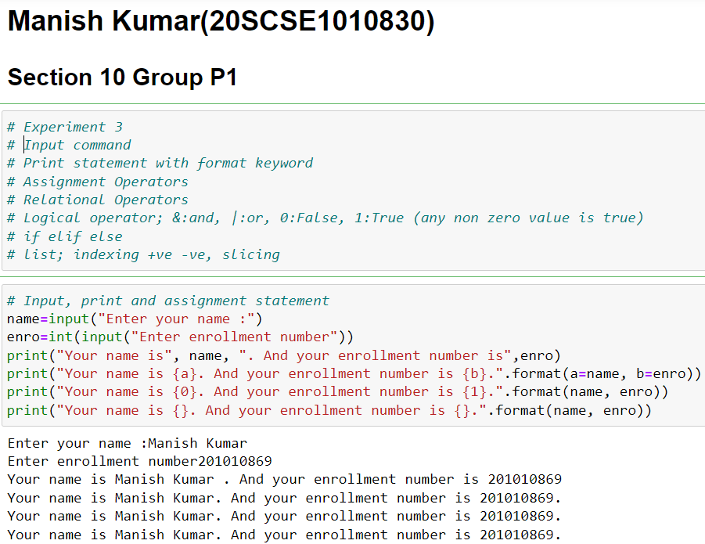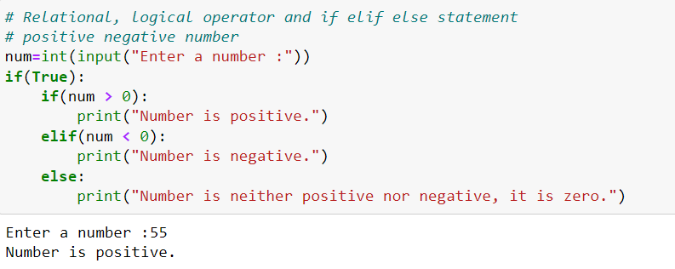

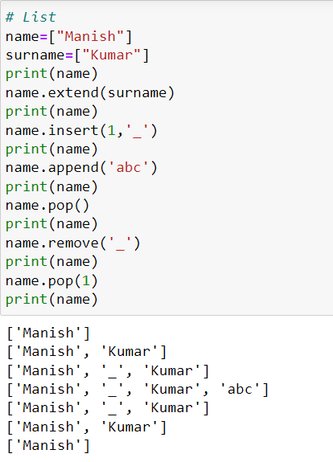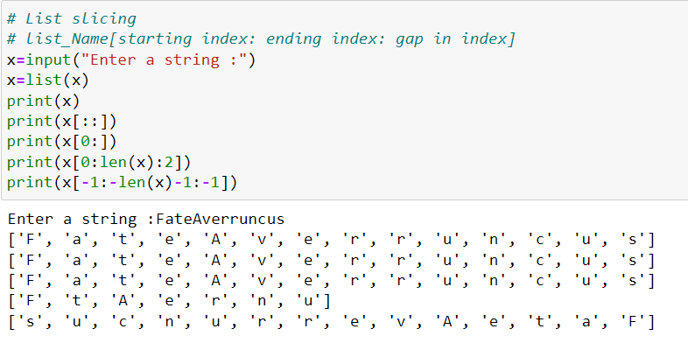

**Conclusion:** Successfully executed the use of Input command, print statement with format keyword, assignment operators, relational operators, logical operator, if-elif-else statements, list concept on jupyter platform.